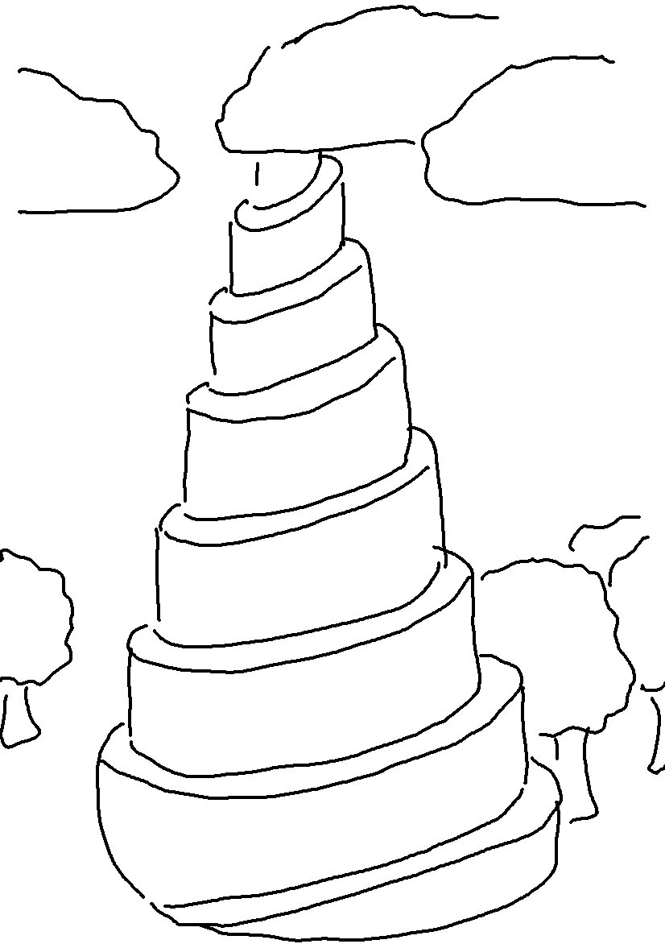
For the Lord _ _ _ _ _ _ _ _ those He _ _ _ _ _. Proverbs 3:12_{NLT}

